AMAZON SES Production Access

# Production Access:

Production Access in Amazon SES , will let you send email to unverified email addresses. To avoid spammers the SES will be in sandbox mode.

You need to make your SES account production ready.  
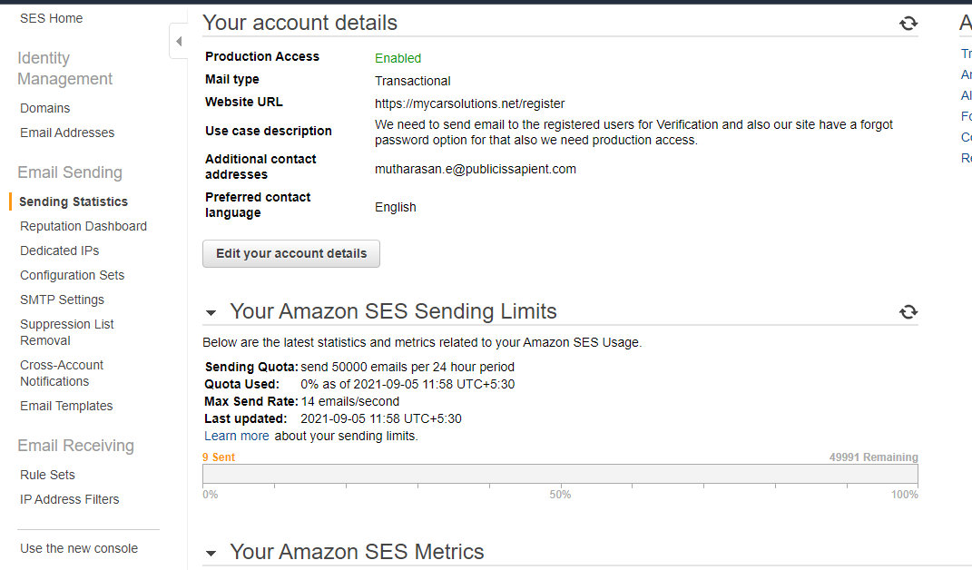

In the above image you can see the production access is enabled. At first time , It will be in sandbox mode. You can apply for production access using edit your account details button. There you will need to give your mail type , website url and use case description. If the access is denied you can reopen the ticket or create a new ticket and again ask for the access.

# Verify Domain

For using your domain emails you need to verify your domain by going to domain tab and add your domain name , there will be text file , that will have a key pair value , you need to add it to your domain dashboard. Then you domain also will be verified.